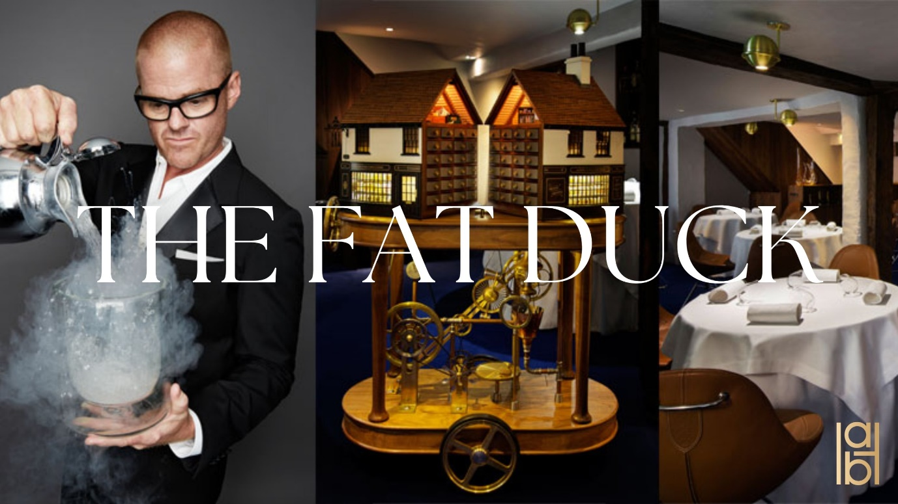

Leveraging AI: To improve Recipe Research and Development in the Food Sector within the Context of The Fat Duck
UMKDWV-15-M - Artificial Intelligence
Luke Hammond
21013675
Word Count – 3480

  - Table of Contents
- Introduction
- Selected Technology and Market Analysis
- Chosen Organisation and AI Problem
- Disruption and Market Changes
- Solution to the Identified AI Problem
- Future Possibilities and Trends
- Recommendations
- Conclusion
- Reference

Introduction
The intention of this report is to investigate the extent to which recipe research and development (R&D) can be aided by AI and the further impacts of such an investigation such as improvements to supply chain and improved customer experience. The current foodtech markets value is set to increase by 2029 (Ewing-Chow, 2025), due to advancements in technology and AI. Following customer needs of restaurants being more sustainable and ethical (Mintel, 2024), it is possible for AI tools such as Natural Language Processing, Predictive Analytics, Machine Learning and Big Data to assist in satisfying those customer needs.
This investigation, which can be applied to most of the industry will focus on the context of The Fat Duck which has received the ultimate culinary accolade of the Three Michelin Stars (Michelin, 2020). Exploring a market leader will enlighten issues at the top level which other restaurants may be susceptible to. These issues surround the possibility of a weak supply chain which can ultimately lead to paying inflated prices for items (Seo, 2024) as well as the ethical issues of collecting customer.
The previously stated AI tools are constantly evolving (Dataversity, 2024) and in an ever-evolving world, businesses from all sectors need to adapt to the inevitable change and work to coexist with AI “not as its masters, but as its collaborators” (Time, 2025). AI is currently able to create basic recipes from ingredients supplied by a user (Chu, 2021), however future developments seen through machine learning are establishing flavour models and research time is being saved through AI simulating flavour responses (CAS, 2024). Eventually, AI will understand food down to a chemical level (Brightseed, 2025) and create dishes that are objectively harmonious. Therefore, early adoption to collect big data and create an assistant in AI is crucial for restaurants to keep a competitive advantage in its innovation stage, an aspect that is key to a gastronomy restaurant such as The Fat Duck (The Fat Duck, 2025).

Selected Technology and Market Analysis
Natural Language Processing (NLP)
NLP helps computers understand, interpret and utilise human language, this enables computers to communicate with people (Foote, 2023). NLP can be dated back to 1950 where it was initially developed by Alan Turing in his seminal paper Computing Machinery and Intelligence (Aveni, 2025). Four years later a collaboration between Georgetown University and IBM translated 60 Russian sentences into English using rule-based algorithms (Aveni, 2025). Since 1950 there have been developments within the field of NLP and new tools such as Google Translate or in more recent times GPT-4. NLPs are important today with its vital role to bridge human language and machine understanding (Aveni, 2025). NLPs are already in use in a wide range of industries, and this is also the case in the food industry where its being researched how they can be utilised to analyse nutritional and sustainability of recipes and foods (Erp, et al., 2021).
Predictive Analysis
Predictive analysis could be dated back to 1698 where the Lloyd Company used it to underwrite insurance for sea voyages (Medium, 2019). However, during the rise of technology predictive analysis has undergone the evolution of describing events, analysing why it happened to more recently discussing the question of what will happen (Medium, 2019). The purpose of Predictive analysis is to utilise data and patterns to improve accurate decision making while lowering description costs (Medium, 2019). These factors can be found across all industries but in the realm of cooking and food the application of predictive analysis can predict seasonal ingredients for trending future points or forecast disruptions in supply chain which could affect recipe R&D. Researchers are also exploring predictive modelling for optimal cooking across a variety of machinery and methods (Lin, et al.,2021).
Machine Learning (ML)
ML is a very important tool in a multitude of sectors such as cloud computing and e-commerce (Foote, 2021). The application of ML improves computer systems and by utilising ‘training data’ can aid in making decisions (Foote, 2021). In the context of the cooking industry, the application of ML will create hyper-personalised dining experiences due to the ability to experiment with dishes backed by flavour probability models (Ji, et al., 2023). This is significant in the context of The Fat Duck as it’s a market leader, due to its high level of innovation and groundbreaking approaches (Michelin, 2020) based on its influence in gastronomy and Heston Blumenthal’s uniqueness. ML can aid in recipe R&D, to imitate Heston’s approach as well as cross compare previous recipes and research. Additionally, intervening and detecting irregularities in food preparation could have diminished the effects of the 2009 closure of The Fat Duck due to a food poisoning scare (Lewis, 2009).
Big Data
The ML research which would be extremely large and diverse refers to Big Data (Google, 2025). Big Data took off in the 20th Century when the American government needed to track contributions Americans and employers (Firican, 2022). In 2005 Roger Mougalas coined the term Big Data which has now evolved into an AI tool used industry wide (Firican, 2022). The application of Big Data within the cooking industry is still in its infancy (Tao, et al., 2021) therefore the implications of Big Data is currently hard to judge. However, based on its impacts in other sectors such as healthcare where it is being used to further research due to medical research having large quantities of data to drive important medical breakthroughs (Coursera, 2025). Therefore, it is possible Big Data can be utilised in a similar manner within the cooking industry enabling The Fat Duck to improve their supply chain and recipe R&D.

Chosen Organisation and AI Problem
The philosophy behind The Fat Duck is innovation, “seeking to create dishes that delight and inspire” (The Fat Duck, 2025). Dishes drawing on science, history and curiosity. Accompanying certain meals are external factors such as sounds, music or machinery to change how the dish is experienced (Steven, 2017). These experiences are extremely personal and are intended to work in tandem with the persons memory. Due to these personal experiences and innovation being at the forefront of The Fat Ducks positioning they have a separate location for creativity due to the “professional kitchen not being creative […] it’s a manufacturing line” (Miele, 2017). Unfortunately, The Fat Duck doesn’t not publicly state whether they use AI tools nor what technology they use, however by looking at similar restaurants and Heston Blumenthal’s current hand in AI machinery (Katwala, 2020), safe assumptions can be made as to what equipment and tools they currently use.
For instance, The Fat Duck utilises cooking techniques that work harmoniously with science to create the greatest dishes possible. Through optimal taste and texture, it can aim to reduce food wastage by reducing the likelihood of discarded food. Subjectivity leaves room for improvement as there is always preference in food which can be tapped into with NLP and ML. Guests may still leave food remnants due to inconsistencies caused by the cooking or because they do not like the flavour or texture. These are all areas that can be further pushed and improved upon especially to ideally reach 0% food waste. Additionally, in-house services such as food inventory tracking will consistently become outdated, therefore there is always improvement available, in the case of The Fat Duck, who source locally (Desklib, 2023) they could face a disruption of inventory which may affect their ability to create the future menus but potentially their opening times for perhaps a limitation in food quantity. Moreover, inflation in the supply chain and staff cost has led to an increase in pre-tax loss (Seo, 2024). Inventory control can be seen developing now with the likes of Restoke in Australia who provide an AI platform to assist restaurants in automating operations (Restoke, 2025), which could help lessen the impact of previous points.
Furthermore, The Fat Duck use techniques which depends on the understanding of science and gastronomy (The Fat Duck, 2025). Techniques such as spherification which are prone to human error for a reason such as a misunderstanding of instructions or the repetitive nature in such a fast environment. The Fat Duck, like many restaurants live in a fast tempo environment which can cause injuries to chefs. As detailed by the Telegraph, The Fat Duck was sued due to a chef developing repetitive strain injury (Stephens, 2021) from the tempo and overbearing nature of the work needed from The Fat Duck.

Disruption and Market Changes
The UK food industry is currently seeing a rise in importance of sustainability, seeing a 5% increase between 2023 and 2024 in customer priority when eating out or ordering takeaway, showcased in Figure 1 (Mintel, 2024). This links to the movement of Brits becoming more environmentally friendly during 2023, 25% of adults said their lifestyle is more environmentally friendly now than a year ago (Mintel, 2024).
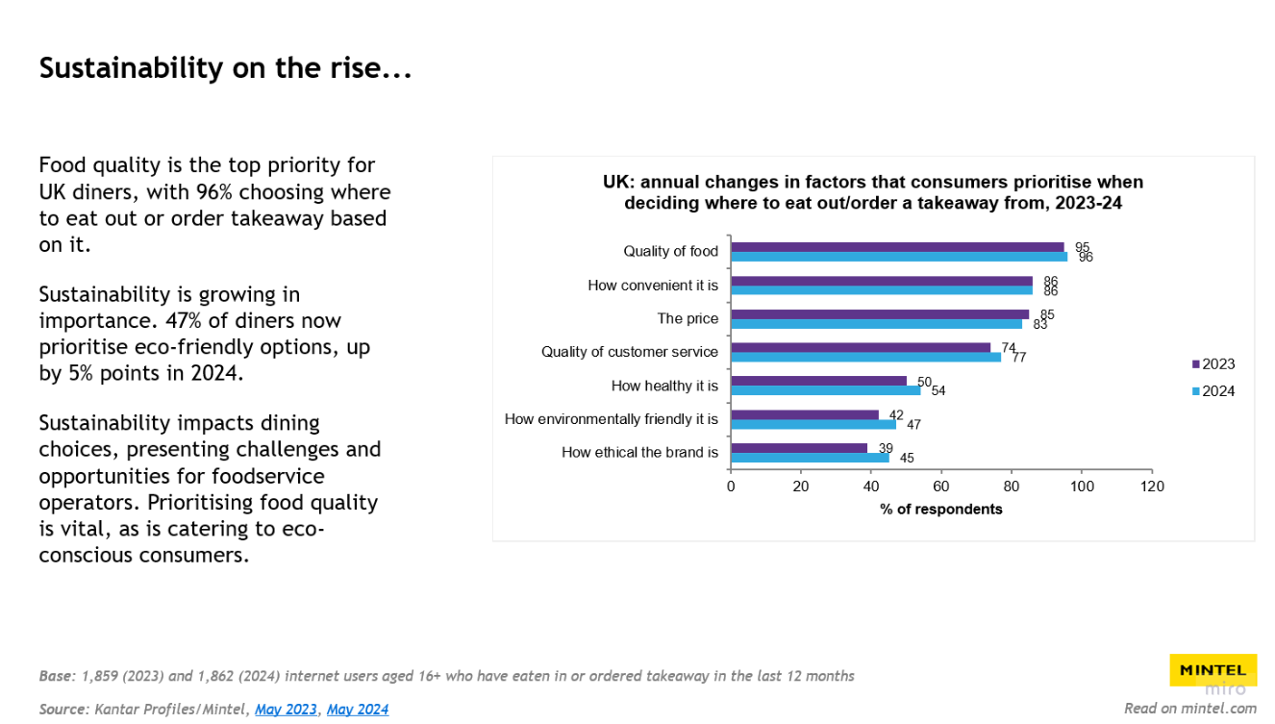
Figure 1 - UK customer priority chart
Additionally, the ethical nature of a brand has been brought into question being the most prioritised factor of a customer’s decision when choosing where to eat (Mintel, 2024), this can be seen with the boycotting of McDonalds (Newlands, 2024).
To coincide with these customer needs the industry has seen a shift in their approach of sourcing food and tackling variable crop yields through AI tools and software (CAS, 2024). In the United States, 30% of all food and drink is discarded annually (CAS, 2024), however by utilising AI tools such as predictive analysis, the industry can more accurately forecast weather patterns and improve crop yields. Additionally, smart fridges such as the Samsung Family Hub can track food inventory and suggest recipes based on current ingredients and recommend which ones to buy when shopping to complete a recipe (Gupta, 2024).
Overall, the food industry is seeing an increase in sustainability and upholding ethical practices to satisfy customer wants/needs however also due to a rising number of laws pushing ethical practices. For example, plastic pollution requires restaurants to use alternative methods to some plastic appliances (Shrawner, 2023) or the waste regulations which requires businesses to separate their waste into different categories for recycling (GOV.UK, 2024).
The industry and more specifically home cooking is starting to embrace the AI world as seen with the AI-driven foodtech market, which is projected to be worth $27.73 billion by 2029 (Ewing-Chow, 2025). If the industry were to implement AI, they could utilise it to track inventory to reduce food waste which will save money and resources increasing annual income which could be utilised to improve facilities or reinvest into recipe R&D. In addition, they could enhance their understanding of food, Brightseed’s Forager is an AI tool which aims to understand plant-based bioactives (brightseed, 2025). This analyses the plant to the molecular level and aims to uncover potential health benefits (CAS, 2024), which will enable unique and beneficial recipe ideas. The concept of this AI tool would suit The Fat Duck well in their pursuit of science and innovation, as well as assist the chefs in creating a chemically structured dish. Furthermore, AI software can assist in the creation of recipe making from existing inventory ingredients as previously established. While this faces the moral challenge of reduced creativity, if used as support rather than a builder, AI can assist The Fat Duck but also the industry in developing greater recipes.
The Fat Duck is a restaurant that creates a deeply personalised experience for a consumer and ML as well as NLPs can aid in improving that experience by profiling or data gathering the customer base for a more hyper-personalised experience (Pandya, 2023). However, profiling of customers is a grey area especially in the context of ML, the best practises as of 2025 is being transparent about data collection and usage as well as allowing customers to back out of data gathering at any given time (Durham, 2020). Additionally, ML is capable of developing biases towards demographics, perhaps favouring one customer group’s opinion more than another. This type of bias can be seen in the case of the ML developed for the American Juridical system which has been flagged for a potential racial bias in its algorithm (Piano, 2020). In the case of restaurants, ML could possibly develop biases that favour certain cultural foods over others, which is significant as it could potentially reduce innovation in the industry. Therefore, the importance of transparency is not to be understated to alleviate these issues from occurring.

Solution to the Identified AI Problem
While The Fat Duck consistently ranks within the top 50 best restaurants in the world (Sansom, 2020), there are still areas that can be improved through the implementation of AI. The manufacturing line can be more productive and efficient with ingredient control and reduce wastage with the application of AI tools such as Big Data and Predictive Analytics. Watching trends in seasonal food and examining how many people visit The Fat Duck AI can calculate inventory for the pantry ultimately making The Fat Duck more sustainable, a clear negative to this is the possibility for error in calculation and external world factors that cannot be calculated. However, AI should be able to reduce human error as seen in the data analytics industry where AI can achieve more accurate insights and recommendations than humans can (Miller, 2023).
AI can be applied to The Fat Duck to aid in flavour modelling and trend predictions. Successful combinations from the past stored via Big Data can add further research for cross comparison and material to further the flavour model (Tao, et al., 2021). Mentioned before, The Fat Duck creates personal experiences, this is all data that can be analysed from guest experiences which can also aid in the flavour modelling to understand what is best but also what can be improved upon. While the application of AI would support flavour modelling it could also cause challenges such as the potential loss in creativity, a big part of The Fat Ducks identity is creativity. Over-reliance on AI generated flavouring could negatively affect chef’s creativity but also impact upcoming chefs who are trained to follow models rather than innovate independently (Granados, 2022). Therefore, the approach for The Fat Duck would be to utilise AI as a support to enhance dishes and for chefs to learn alongside the AI for harmonious human and AI creativity.
Adjacent to The Fat Ducks creativity is their high level of personalisation, every experience is to be a unique and personal one for the guests (The Fat Duck, 2025). This process begins from booking the event to leaving and reviewing; to assist in this personalisation, The Fat Duck could apply AI to assist in delivering a truly unique experience to every guest. NLP is capable of extracting themes and emotions from customer reviews and ML is capable of complex guest profiling to create a hyper-personalised dining experience. This experience will push the creativity and experience further for the guests dining at The Fat Duck, however the negative implications of such profiling is the privacy and ethical concerns of gathering the data, whether guests consent to this data being recorded and how transparent The Fat Duck is with the storage and usage of the data (Durham, 2020). Additionally, AI may struggle to distinguish between the emotional philosophy The Fat Duck provides, creating a technically great dish which lacks the emotional and memory layers of the dish.

Future Possibilities and Trends
AI is forever evolving, Moore’s law dictates that technology becomes two times faster and half as expensive, every two years (Medium, 2019). To identify the long-term objectives of AI is hard to measure, however tracking customer needs is a measurable variable and one that can be predicted, which will ultimately be what shapes the usage of AI and its usage as stated by Ginni Rometty the Former CEO of IBM, “AI will not replace humans, but those who use AI will replace those who don’t” (Time, 2025). The world is integrating AI more and it is having big effects in other sectors such as car manufacturing, where AI has transformed the industry with automated manufacturing via robots who can collect data in real time (Oranim, 2024).
In the case of the food industry which is seeing an increase in customer needs around sustainability and brand ethics, AI tools will and already is being utilised to tackle inventory control to relieve stress on the supply chain (Restoke, 2025) and calculate/predict possible disruptions while suggesting alternative suppliers and ingredients. While there is already established science behind seasonal food, AI can predict external events such as tensions in areas which may result in a lower stock and be able to identify alternatives ahead of time. In the context of The Fat Duck which is increasing in their tax-loss (Seo, 2024), AI tools such as predictive analytics can track, and measure supplies ahead of time which should be able to alleviate the situation of inflation. These kinds of tools will be adopted by most if not all restaurants due to it all restaurants being a business which want to make money.
In addition to inventory control is recipe generation which can already be achieved through NLP tools such as GPT and they are only becoming more advanced (Chu, 2021). Early adoption of NLPs and Big Data to collect and manage recipe findings and successful pairings will push restaurants further in their innovation of new recipes, with The Fat Duck this would equate to maintaining the market lead as well as having potential data that could be sold to other organisations or published in books to raise money which can tackle their fight against inflation. However, to ultimately test the success of dishes it needs to be showcased to customers who review and critique the dishes as well as experience. These experiences can be collected for data to aid the AI but is faced with the challenge of where companies should stop in their data collection (Durham, 2020).

Recommendations
To tackle the challenge of inflation in the market and increasing efficiency in the work stream, The Fat Duck could utilise AI such as Predictive analytics to track current supply chain management and make alterations to it when necessary. This will create less food wastage and alongside technical advancements with AI software’s such as Big Data, guide sustainable sourcing. Furthermore, with the push of sustainability and ethical practices being desired by customers (Mintel, 2024), AI will enable restaurants to satisfy those customer needs.
Steady inventory control will link to recipe R&D as AI can start creating more recipes with estimates of what ingredients will be available once it is required to change the menu. For The Fat Duck, assistance of ML and NLP to assist in the initial innovation stage will create a more efficient work stream and reduces costs on staff who may have to work extra hours to develop these recipes and testing of flavours. Additionally, when paired with data collected from tracking trends and an analysis of guest experiences, The Fat Duck and the industry will benefit from knowing what makes an experience unique to a customer but also what is preferred from customers. While previously established, this could lead to biased dishes, human intervention in these moments will create an AI that works alongside humans rather than one that replaces.
The use of AI flavour modelling can already be noticed in major companies such as Nestle who utilise AI for trend analysis and ingredient exploration resulting in swift ideation and testing of product concepts (CAS, 2024). Therefore, the acceptance of it on a fine-dining level will soon be approaching, as seen by AI being welcomed to the home cooking world (Gupta, 2024). To maintain the competitive advantage that The Fat Duck has as a market leader, implementing AI early to collect data and mimic Heston’s style of innovation and cooking with ML will be key to keeping one up on the industry.

Conclusion
The AI world is constantly evolving and so are customer needs, customers want to know that where they eat is sustainable and an ethical brand. To meet these customer needs AI tools such as predictive analytics and Big Data can manage the supply chain to reduce food wastage and gather ingredients from sustainable sources. Additionally, the tools can be used for predicting seating capacity and inventory control to reach customer quantity, this extra layer in the reduction of food can help, The Fat Duck but also the industry combat inflation in food products.
Furthermore, menu R&D can have an efficiency increase from ML who can create flavour models to aid in innovation but for The Fat Duck add the extra layer of science and creativity by researching food on a molecular level as seen with Brightseed’s Forager (Brightseed, 2025). The future of AI in the food industry is set to rise (Ewing-Chow, 2025) and those that adopt the earliest will be the ones who lead the way in the generation of AI cooking.

Reference
Aveni (2025) The Fascinating History of NLP: 9 Key Milestones from Turing’s Test to AI Language Models. Available from: https://aveni.ai/blog/history-of-nlp/ [Accessed 07 May 2025].
Brightseed (2025) A Faster Path to Discovery. Available from: https://www.brightseedbio.com/technology [Accessed 07 May 2025].
CAS (2024) Embracing the future of AI in the food industry [online]. Washington, D.C: American Chemical Society. Available from: https://www.cas.org/resources/cas-insights/embracing-future-ai-food-industry [Accessed 07 May 2025].
Chu, J. (2021) Recipe Bot: The Application of Conversational AI in Home Cooking Assistant. 2021 2nd International Conference on Big Data & Artificial Intelligence & Software Engineering (ICBASE) [online]. [Accessed 08 May 2025].
Coursera (2025) Big Data in Health Care: What It Is, Benefits, and Jobs. Data Analytics [blog]. 14 April. Available from: https://www.coursera.org/articles/big-data-in-healthcare [Accessed 07 May 2025].
Dataversity (2024) Dataversity. Available from: https://www.dataversity.net/ [Accessed 09 May 2025].
Department for Environment, Food & Rural Affairs (2024) Simpler recycling: workplace recycling in England. Available from: https://www.gov.uk/guidance/simpler-recycling-workplace-recycling-in-england [Accessed 09 May 2025].
Desklib (2023) The Fat Duck Restaurant: Food Supply Chain, Procurement and Ethics [online]. Available from: https://desklib.com/study-documents/food-supply-chain-fat-duck/ [Accessed 09 May 2025].
Durham Pro Bono Blog. (2020) The Legal Ethics of Data Profiling. Durham Pro Bono Blog [blog]. 03 March. Available from: https://www.durhamprobonoblog.co.uk/post/the-legal-ethics-of-data-profiling [Accessed 08 May 2025].
Erp, M.V, et al. (2021) Using Natural Language Processing and Artificial Intelligence to Explore the Nutrition and Sustainability of Recipes and Food. Artificial Intelligence [online]. 3. [Accessed 07 May 2025].
Ewing-Chow, D. (2025) The Latest AI Trends Transforming The Food Industry. Food & Drink [online]. [Accessed 07 May 2025].
Firican, G. (2022) The history of big data. Lightsondata [blog]. 17 January. Available from: https://www.lightsondata.com/the-history-of-big-data/ [Accessed 07 May 2025].
Foote, K.D (2021) A Brief History of Machine Learning. Smart Data News, Articles & Education [online]. [Accessed 07 May 2025].
Foote, K.D. (2023) A Brief History of Natural Language Processing. Smart Data News, Articles & Education [online]. [Accessed 07 May 2025].
Google Cloud (2025) What is Big Data. Available from: https://cloud.google.com/learn/what-is-big-data [Accessed 09 May 2025].
Granados, N. (2022) Human Borgs: How Artificial Intelligence Can Kill Creativity And Make Us Dumber. Hollywood & Entertainment [online] [Accessed 09 May 2025].
Gupta, R. (2024) How AI Is Taking Over Our Kitchens. Innovation [blog]. 16 July. Available from: https://www.forbes.com/councils/forbestechcouncil/2024/07/16/how-ai-is-taking-over-our-kitchens/ [Accessed 08 May 2025].
Ji. H, et al. (2023) Recent advances and application of machine learning in food flavor prediction and regulation. Trends in Food Science & Technology [online]. 138. [Accessed 09 May 2025].
Katwala, A. (2020) Heston Blumenthal wants robots to make your boring lunch. Science [blog]. 19 February. Available from: https://www.wired.com/story/heston-karakuri/ [Accessed 08 May 2025].
Lewis, P. (2009) Fat Duck food poisoning caused by shellfish contaminated with sewage, report suggests. The Guardian [online]. 10 September. Available from: https://www.theguardian.com/uk/2009/sep/10/fat-duck-food-poisoning-sewage [Accessed 09 May 2025].
Lin, C.S, Pan, Y.C., Kuo, Y.X., Chen, C.K., Tien, C.L. (2021) A Study of Automatic Judgment of Food Color and Cooking Conditions with Artificial Intelligence Technology. Processes [online]. 9 (7). [Accessed 07 May 2025].
Medium (2020) A Brief History of Predictive Analytics. Available from: https://medium.com/@predictivesuccess/a-brief-history-of-predictive-analytics-f05a9e55145f [Accessed 07 May 2025].
Michelin Guide (2020) The Fat Duck: 25 years of Innovation. Michelin Guide [blog]. 08 October. Available from: https://guide.michelin.com/gb/en/article/features/the-fat-duck-25-years-of-innovation [Accessed 07 May 2025].
Miele (2017) The Fat Duck’s Heston Blumenthal. The World’s 50 Best Restaurants [blog]. Available from: https://www.miele.com/brand/en/the-fat-ducks-heston-blumenthal-33835.htm [Accessed 07 May 2025].
Miller, A. (2023) How AI Helps Prevent Human Error In Data Analytics. Insideainews [online]. 18 March. Available from: https://insideainews.com/2023/03/18/how-ai-helps-prevent-human-error-in-data-analytics/ [Accessed 09 May 2025].
Mintel (2024) Sustainability in Foodservice – UK – 2024 [online]. London: Mintel. Available from: https://clients.mintel.com/content/report/sustainability-in-foodservice-uk-2024 [Accessed 26 April 2025].
Newlands, C. (2024) McDonald's: Behind the fast-food firm's boycott controversy. BBC News [online]. 05 April. Available from: https://www.bbc.co.uk/news/business-68740617 [Accessed 09 May 2025].
Oranim, R. (2024) The Impact and Benefits of AI in the Automotive Industry. Fullpath [blog]. 04 February. Available from: https://www.fullpath.com/blog/the-impact-and-benefits-of-ai-in-the-automotive-industry/ [Accessed 09 May 2025].
Pandya, Y. (2023) How is AI revolutionizing the culinary world through personalized food recommendations?. Medium [blog]. 23 October. Available from: https://medium.com/@yagnesh.pandya/how-is-ai-revolutionizing-the-culinary-world-through-personalized-food-recommendations-b7e45628993e [Accessed 10 May 2025].
Piano, S.L. (2020) Ethical principles in machine learning and artificial intelligence: cases from the field and possible ways forward. Humanities and Social Sciences Communications [online]. 7 (9). [Accessed 08 May 2025].
Restoke (2025) Your restaurant. Your rules. Available from: https://www.restoke.ai/ [Accessed 09 May 2025].
Sansom, M. (2020) The Fat Duck at 25 – how Heston Blumenthal defined modern gastronomy. 50 Best [online]. 17 August. Available from: https://www.theworlds50best.com/stories/News/how-heston-blumenthal-defined-modern-gastronomy.html [Accessed 07 May 2025].
Seo, J (2024) Fat Duck Group reports £1.4m loss. The Caterer [online]. 11 June, Available from: https://www.thecaterer.com/news/fat-duck-group-reports-14m-loss?utm_source=chatgpt.com [Accessed 08 May 2025].
Shrawner, D. (2023) Restaurant Plastic Waste: Today’s Facts and Future Solutions. Unsustainable [online]. 02 May. Available from: https://www.unsustainablemagazine.com/restaurant-plastic-waste-guide/ [Accessed 09 May 2025].
Stephens. M. (2021) Heston Blumenthal’s Fat Duck sued by pastry chef who was 'forced to make 550 whisky wine gums a day. The Telegraph [online]. 13 December. Available from: https://www.telegraph.co.uk/news/2021/12/13/heston-blumenthals-fat-duck-restaurant-sued-pastry-chef/ [Accessed 09 May 2025].
Steven, R. (2017) WORK: Seymourpowell’s mechanical sweet shop for The Fat Duck. Creative Review [blog]. 15 March. Available from: https://www.creativereview.co.uk/work/work-mechanical-sweet-shop-heston-blumenthal-fat-duck/ [Accessed 07 May 2025].
Tao, Q. et al. (2021) Application Research: Big Data in Food Industry. National Library of Medicine [online]. [Accessed 07 May 2025].
The Fat Duck (2025) The Fat Duck. Available from: https://thefatduck.co.uk/ [Accessed 24 February 2025].
Time (2025) 15 Quotes on the Future of AI. Available from: https://time.com/partner-article/7279245/15-quotes-on-the-future-of-ai/ [Accessed 07 May 2025].

